# Module 3 Main Assignment Joona Räisänen M2080

Model 1 Barrel. UV unwrapped, texture painted in gimp. 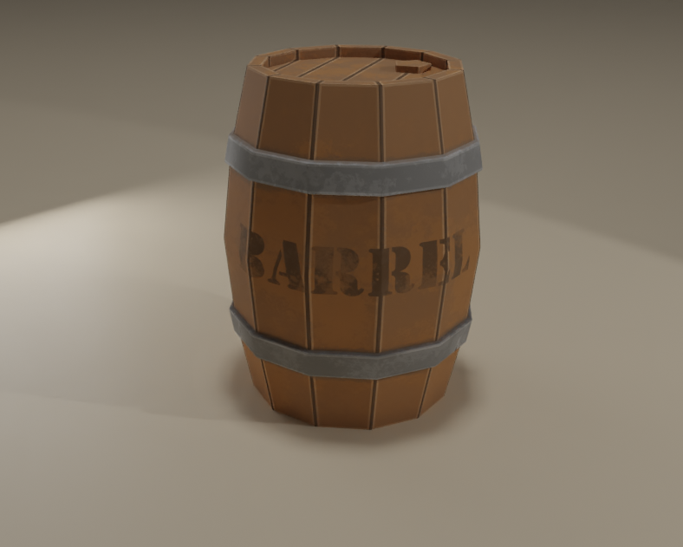

Material setup for barrel.

Texture painted in Gimp by exporting the barrel UV map for guidelines.

Model 2 mug.

Material setup for the wood.

Material setup for the metal parts.

Material setup for the drink/potion. 